Zoom Quick Reference Guide

Interface Overview – Main Functions
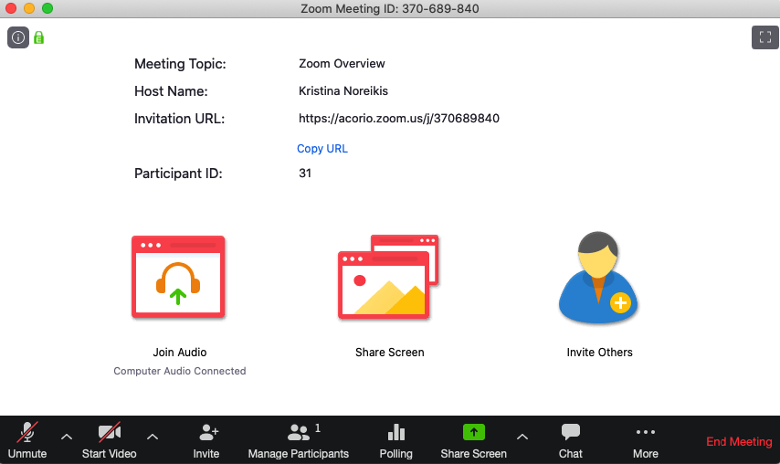  3  1  2  4  5 | - Mute or unmute you microphone  - Start or stop your video feed  - Manage or view a list of meeting participants  - Share your screen with participants  - Chat with the meeting participants
Configure Audio and Video
- Select caret next to the microphone icon to choose/verify your speaker and microphone selection
- Click on the microphone icon to mute/unmute your microphone

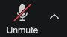
- Select caret next to the video icon to choose/verify your video camera selection
- Click on the camera icon to start/stop your video stream

Using Non-Verbal Feedback
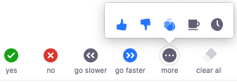

- Open Participants list to view the non-verbal feedback icons
- Select more to find additional options
- Mouseover each icon to see suggested meaning for each icon

Screen Sharing Settings for Hosts
https://zoom.us/profile/setting Allow whiteboard share, Mute attendees upon entry, Set a co-host for each call

